**Web Tutorial ~ Checking In materials with the S.O.A.R Circulation Program**

**Mary Kay Nielsen**

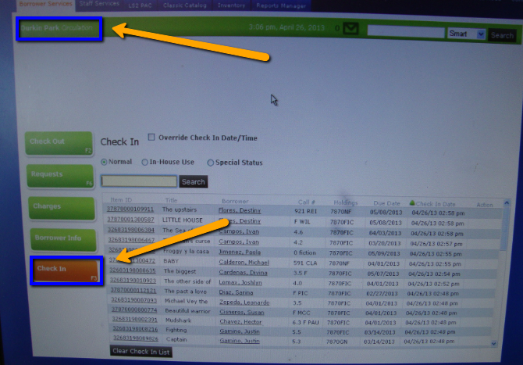

1. On the S.O.A.R. home

page, select the fifth tab labeled “Check In”. Once selected the tab color will change from green to orange.

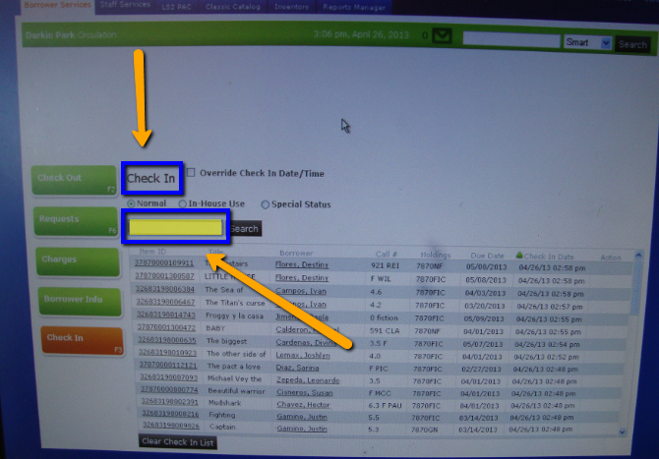

2. The screen heading will now read “Check In” and the rectangular Search Box in the middle of the screen will be highlighted.

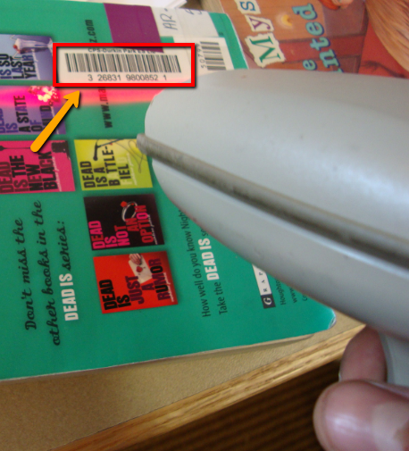

3. Locate the CPS Durkin Park barcode placed on the inside cover of the book or on the back of the book. Using the scanner, squeeze the trigger and aim the red light at the barcode. You will hear a beep when the scanner “sees and reads” the barcode.

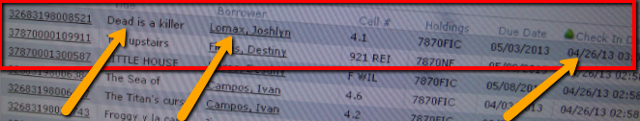

4. Check the screen to see that the book has been logged into the system. You should see the following information about the book now logged into the system and in the Information Grid: “Item ID, Borrower, Call #, Hold, Due Date, Check In Date”. Please note that at times the scanner will make a beeping sound but not log the book into the system. If the information is not recorded for the scanned book in the Information Grid, you may have to enter the book manually.

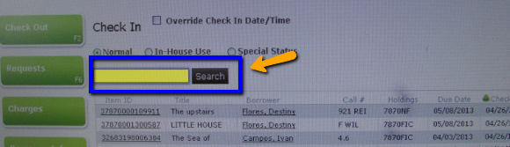

5. To manually enter the book, move the mouse/curser to the Search Box above the Information Grid and left click on the mouse. The Search Box will now will be highlighted. Type in the numbers below the CPS Durkin Park barcode and press “enter” on the keyboard.

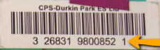



6. The information about the book will now be present in the Information Grid.



7. Before scanning or manually entering the next book, make sure that the Search Box above the Information Grid is highlighted and ready for you to scan or enter the barcode numbers. If not left click with the mouse on the Search Box to highlight/activate the box and proceed checking in returned books using these steps 2-6.